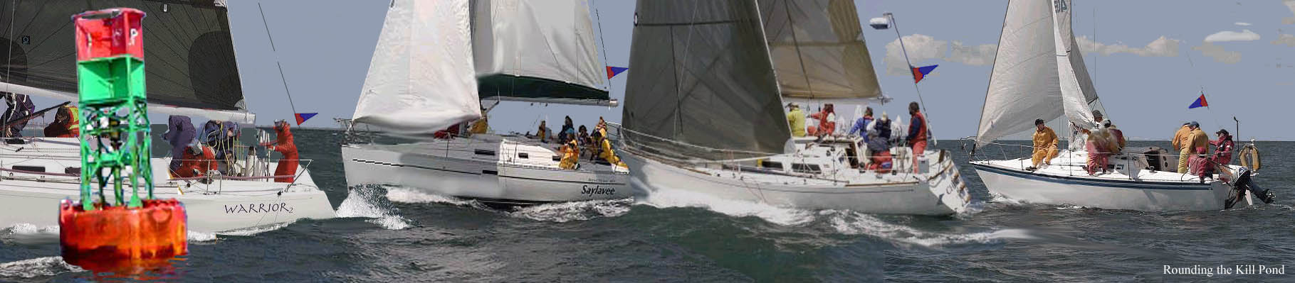

Richard T Wales Cup Cruising Regatta
(No spinnakers to be flown)

2009 REGATTA ENTRY FORM

Saturday, September 19, 2009

YACHT NAME:

SKIPPER/OWNER:

ADDRESS:

TOWN: STATE: ZIP:

PHONE: EMAIL ADDRESS:

SKIPPER’S CLUB (N/R):

US SAILING MEMBER NUMBER:

NON-SPINNAKER ( ) MAKE: SAIL#:

PHRF Racing Rating: PHRF Cruising Rating: TYPE:

ENTRY FEE: $ 20 # OF PERSONS ATTENDING PARTY

Please complete and send this form and your $20 check to:

Tom Leach

P.O. Box 207
Harwich Port, MA 02646

Please continue on the next page

WAIVER and RELEASE

I accept full responsibility for the conduct of each member of my crew and guests during the 2009 RICHARD T. WALES CUP Regatta and post race activities and acknowledge responsibility for the safety of my crew and yacht.

The 2009 RICHARD T. WALES CUP is not responsible for accidents, damage or injury to property or to yachts, crew or guests arising from any cause during or related to any race or activities of the 2009 RICHARD T. WALES CUP Regatta. I and my crew will evaluate the weather and sea conditions and are responsible for determining whether it is safe for us to participate and continue participating in the regatta. The responsibility of wearing life jackets rests upon me and my crew. If assistance is provided by Race Committee vessels, personnel, or 2009RICHARD T. WALES CUP members I and my crew will not hold any of them responsible for any injury, death or damage resulting from their actions to assist us.

I agree that my yacht will be outfitted, equipped and handled in accordance with these conditions; that she will have all of the required and necessary equipment aboard; that she is seaworthy in hull, rig and gear; and that she will be completely manned.

- My crew and I recognize that sailing is an activity that has an inherent risk of damage and injury associated with it. We have read RRS 4, Decision to Race, and hereby acknowledge and agree that we are participating in this event entirely at our own risk.
- I acknowledge and agree that neither the 2009 RICHARD T. WALES CUP, the Race Committee, their officers, trustees or members, will be responsible for:
- (a) any damage to my yacht or my other property, or
- (b) any injury to me or my crew, including death, sustained as a result of the participation of me, my crew and my yacht in this event.
- I hereby waive any rights I may have to sue the race organizers (organizing authority, Race Committee, protest committee, 2009 RICHARD T. WALES CUP, sponsors, or any other organization or official) with respect to personal injury or property damage suffered by me or my crew as a result of our participation in this event and hereby release the race organizers from any liability for such injury, death or damage to the fullest extent permitted by law.
- I have taken all necessary steps to ensure that I, my crew and my yacht are adequately prepared for all possible contingencies, including appropriate safety equipment as may be required by law or that a prudent seaman would consider advisable.
- I understand this document has important legal consequences and have consulted such legal and other advisors as I deem appropriate before signing below.

In consideration of acceptance of my entry for the 2009 RICHARD T. WALES CUP Regatta, I, my executors, administrators and assigns, waive and release any and all claims that they may have against the 2009 RICHARD T. WALES CUP, their officers, trustees , members, committee men/women, volunteers, employees and agents or any one or more of them or their executors, administrators, heirs, next of kin, successors, or assigns, including any or all claims for damage caused by the negligence of any of them arising out of my participation or that of my yacht in the 2009 RICHARD T. WALES CUP Regatta and its related activities, including pre-start and post finish operations and shore activities together with any costs and expenses including attorney's fees that may be incurred as a result of any such claims that I, any crew member, or any guest (or their executors, administrators, heirs, next of kin, and assigns) may have or assert together with any costs and expenses including attorney's fees with respect thereto.

I agree to all of the conditions of the 2009 RICHARD T. WALES CUP Regatta and shall inform each member of my crew of these conditions.

SKIPPER’S/OWNER’S Signature: Date:________

